**Plaza Premium Group appoints Global Head of ESG & Sustainability, commits to UN Global Compact**

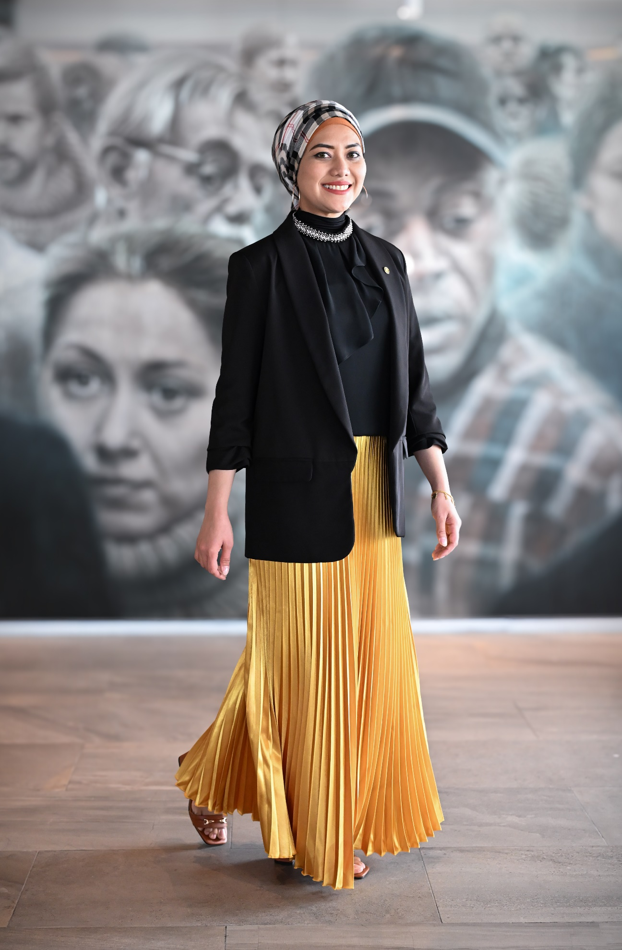

[HONG KONG, 20 May 2024] – Plaza Premium Group (PPG), the leading global airport hospitality services provider, has appointed Dr. Syafrina Sharif as the Global Head of ESG & Sustainability, effective immediately.

Dr. Syafrina is an international sustainability expert with a proven track record of formulating, implementing and driving impactful sustainability strategies and communications, training programs, outreach initiatives as well as commercial engagements.

In the past decade, she has been actively promoting and leading the corporate sustainability agenda at multinational companies in industries of engineering and construction as well as biotechnology. Based in Kuala Lumpur, she has also been supporting the development of Malaysia’s National Planetary Health Action Plan.

“As our business has expanded to a host of airport hospitality ranging from Aerotel hotels, to innovative dining outlets, and concierge services, PPG has adopted more sustainable practices and products throughout our ecosystem. We built this business from the ground up in 25 years, and we are committed to growth for the next 25 years and beyond as a responsible steward within the travel and tourism industry,” said Mr. Song Hoi-see, founder and CEO of PPG.

“I’m truly elated to be joining a global leader in airport hospitality that is an influential force in an industry for which sustainability is mission critical,” Dr. Syafrina said. “One of PPG’s core business pillars is sustainability, alongside people and digitalisation. This is a testament to PPG’s commitment to operating a business that is not just profitable, but that also profits the planet and society at large. I’m thrilled to be part of that vision and excited to be working together with our people and partners towards making travel better”.

Earlier this year, PPG signed its commitment to the UN Global Compact, the world’s largest corporate sustainability initiative, pledging support to its 10 universal principles related to human rights, environment, labour and anti-corruption. The statement of commitment pledges that PPG will support and align with the 10 principles of the UN Global Compact in its strategy, culture and day-to-day operations.

PPG is planning to conduct a materiality assessment later this year, which will be followed by the development of a sustainability strategy and roadmap. These initiatives aim to enhance PPG's sustainability efforts and effectively manage and reduce its environmental footprint in its operations.

Media Contact:   
Whitney Fung ([whitney.fung@plaza-network.com](mailto:whitney.fung@plaza-network.com))

PR and Corporate Communications  
Plaza Premium Group

About Plaza Premium Group

Plaza Premium Group, headquartered in Hong Kong and established in 1998, is a pioneering global airport hospitality services provider. With a mission to Make Travel Better, the group introduced the world's first independent airport lounge concept. Today, PPG operates the largest network of international airport lounges worldwide and offers a 360-degree airport experience with 13 brands under its portfolio, spanning over 250 locations across more than 80 airports worldwide. From airport lounge brands - Plaza Premium Lounge & Plaza Premium First, to terminal hotels - Aerotel & Refreshhh by Aerotel, to concierge services - ALLWAYS, a range of airport dining concepts, global reward and membership program - Smart Traveller, and travel experience ECOsystem - oneTECO, the group is at the forefront of transforming airport experience for the better through innovative and human-led solutions.

PPG’s commitment extends beyond its own brands, as it also provides lounge management and hospitality solutions to leading airlines, alliances, and corporates worldwide. Partnerships include renowned names such as American Express, Capital One, Cathay Pacific Airways, SkyTeam, Star Alliance, Visa, and many more.

Plaza Premium Group has over 70 accolades demonstrating its exceptional achievements and commitment to service excellence. Notably, the group has received the prestigious "World's Best Independent Airport Lounge" award at the World Airline Awards by Skytrax for seven consecutive years from 2016 to 2023. TTG Asia also recognized the group as the "Best Airport Lounge Operator". In 2020, it achieved the "ISO 9001:2015" certification for its Hong Kong Headquarters. Furthermore, the group's Founder and CEO, Mr. Song Hoi-see, was awarded the “Ernst & Young Entrepreneur of the Year” and “Master Entrepreneur of the Year Malaysia” in 2018.

With a team of over 3,500 dedicated talents, PPG serves more than 20 million global passengers annually. Through a continuous pursuit of innovation and excellence, the group is experiencing exponential growth globally

To learn more: https://www.plazapremiumgroup.com/

Connect with us: FB, IG, @plazapremiumlounge and WeChat @PlazaPremiumGroup