FOR IMMEDIATE RELEASE
Plaza Premium Group and InJourney Aviation Services Forge Strategic Technology Cooperation to Enhance Airport Hospitality Services in Indonesia

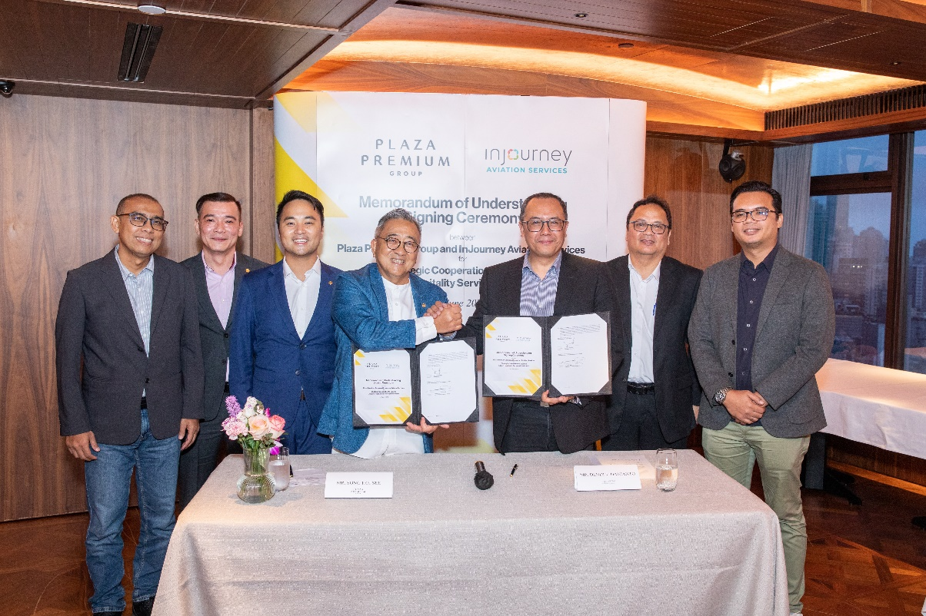
Fourth from left: Mr Song Hoi-See and Mr Dendi Danianto inked the MoU, witnessed by Head of Chancery from the Consulate General of The Republic of Indonesia in Hong Kong, Mr Slamet Noegroho (second from right)

[HONG KONG, 4 June 2024] – Plaza Premium Group (PPG), the award-winning global airport hospitality services provider and InJourney Aviation Services (IAS), the leading provider of aviation services in Indonesia, announced a strategic partnership that will deploy PPG’s technology innovations to elevate airport hospitality services in Indonesia.
This collaboration aims to integrate global standards and innovations from Plaza Premium Group through their premier lounge brand, Plaza Premium Lounge, into lounge service operations at Indonesia’s airports. The initial stage will potentially include five airport lounges managed by IAS, including airports in Jakarta (CGK), Bali (DPS), Balikpapan (BPN), Makassar (UPG), and Medan (KNO), the companies said.
They expect that the partnership will extend to at least 30 airports managed by IAS in Indonesia.
This collaboration is focused on 3 main PPG innovations. They are OneTECO, a system that supports electronic markets and service delivery solutions that enable businesses and consumers to connect and transact securely in the digital economy. Additionally, IAS will adopt PPG’s Lounge Management System which aims to help lounge operators better manage and operate their facilities to create a better experience for guests in the lounges.
On the consumer side, Smart Traveller, a mobile-app based global membership programme powered by PPG, offers a seamless and enhanced travel experience, combining all of PPG’s hospitality offerings into one convenient app, providing members with rewards, exclusive offers, benefits, and service packages.
PPG, which is in more than 250 locations and more than 80 airports globally, provides 360 degree airport hospitality services including premium airport lounges, meet and greet services, and a range of dining options. The company serves 20 million travelers annually across more than 30 countries.
"We are delighted to join hands with InJourney Aviation Services to provide our unique proprietary technology innovations to elevate the operations of airport lounges across Indonesia," said Mr. Song Hoi-see, CEO and founder of Plaza Premium Group. "Southeast Asia is a key strategic market for our business, and Indonesia as the biggest economy in ASEAN and a fast-growing tourism market, presents a significant opportunity for growth. We are incredibly excited to extend to external partners the technology innovations that we have created to improve our operations in our mission of Making Travel Better.”
President Director of InJourney Aviation Services (IAS), Mr. Dendi Danianto, welcomed the partnership as a strategic step for IAS, which aims to upgrade its lounge services to an international standard. "This collaboration will also make it easier for customers to access all services in the lounge and provide comfort and an unforgettable lounge experience," he said.
The agreement capitalises on the significant opportunities arising from Indonesian aviation and tourism sectors. In the 2024 edition of the World Economic Forum's Travel and Tourism Development Index, Indonesia ranked second among ASEAN countries, after Singapore, and 22nd out of 119 countries globally. IATA forecasts growth of 219 percent in the air transport market in Indonesia from 2017 to 2037, which would result in an additional 268 million passenger journeys by 2037.
For more images, kindly download from the link below:
https://mega.nz/folder/7n4yUBjb#QzzCil7JCwfigkxl1Ql9DQ

-END-

Media Contact:
Plaza Premium Group
Cheng Siew Yee [email: siewyee.cheng@plaza-network.com ]
Regional Head of Marketing Communications (Southeast Asia)

Whitney Fung [email: whitney.fung@plaza-network.com ]
Plaza Premium Group PR & Corporate Communications (Global)

InJourney Aviation Services
Cindy Juwita (AVP Public Relation)
Email : corcomm@ias.id

About Plaza Premium Group
Plaza Premium Group, headquartered in Hong Kong and established in 1998, is a pioneering global airport hospitality services provider. With a mission to Make Travel Better, the group introduced the world's first independent airport lounge concept. Today, PPG operates the largest network of international airport lounges worldwide and offers a 360-degree airport experience with 13 brands under its portfolio, spanning over 250 locations across more than 80 airports worldwide. From airport lounge brands - Plaza Premium Lounge & Plaza Premium First, to terminal hotels - Aerotel & Refreshhh by Aerotel, to concierge services - ALLWAYS, a range of airport dining concepts, global reward and membership program - Smart Traveller, and travel experience ECOsystem - oneTECO, the group is at the forefront of transforming airport experience for the better through innovative and human-led solutions.
PPG’s commitment extends beyond its own brands, as it also provides lounge management and hospitality solutions to leading airlines, alliances, and corporates worldwide. Partnerships include renowned names such as American Express, Capital One, Cathay Pacific Airways, SkyTeam, Star Alliance, Visa, and many more.
Plaza Premium Group has over 80 accolades demonstrating its exceptional achievements and commitment to service excellence. Notably, the group has received the prestigious "World's Best Independent Airport Lounge" award at the World Airline Awards by Skytrax for seven consecutive years from 2016 to 2023. TTG Asia also recognized the group as the "Best Airport Lounge Operator". In 2020, it achieved the "ISO 9001:2015" certification for its Hong Kong Headquarters. Furthermore, the group's Founder and CEO, Mr. Song Hoi-see, was awarded the “Ernst & Young Entrepreneur of the Year” and “Master Entrepreneur of the Year Malaysia” in 2018.
With a team of over 5,000 dedicated talents, PPG serves more than 20 million global passengers annually. Through a continuous pursuit of innovation and excellence, the group is experiencing exponential growth globally
To learn more: https://www.plazapremiumgroup.com/
Connect with us: FB, IG, @plazapremiumlounge and WeChat @PlazaPremiumGroup

About InJourney Aviation Services
PT Integrasi Aviasi Solusi or InJourney Aviation Services (IAS) is a sub holding of PT Aviasi Wisata Indonesia or InJourney. InJourney Aviation Services was officially formed on January 4th, 2024, is a consolidation of nine subsidiaries under AP 1, APII and Garuda which will focus on all activities related to airport and cargo services. IAS's 4 main business portfolios are: Ground Handling & Cargo Terminal, Logistics, Hospitality and Operations Support by providing 12 competent and competitive aviation and logistics services. IAS's vision is to become a professional and competent provider of aviation and logistics & cargo services in Indonesia and the region.

Connect with us:
- FB InJourney Aviation Services
- IG @injourneyaviationservices
- Twitter @injourney_IAS
- TikTok @injourney_IAS
- YouTube InJourney Aviation Services

