**For Immediate Release**

**Unique city terminal lounge in Osaka offers comfort for all transport routes**

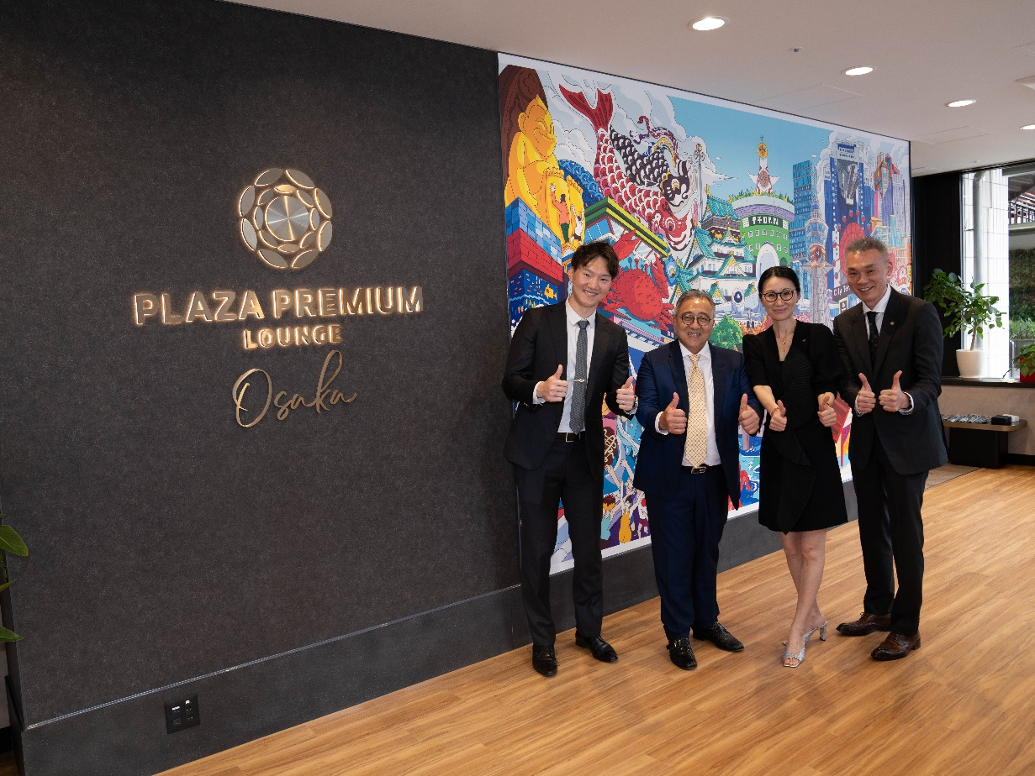

**[HONG KONG, 18 July, 2024] -** Plaza Premium Group (PPG) and Japanese tourism specialist JWIDE debuted a first-of-its-kind hospitality service – the City Terminal by Plaza Premium Lounge – in the Osaka area to serve all travelers, regardless of whether they are taking a plane, train or bus.

The location was selected in the vibrant heart of Osaka, a bustling commercial hub, to be conveniently accessible by various modes of transportation, including buses and trains. The City Lounge is situated within all the major tourist areas within Osaka, as well as within the transportation routes that lead to nearby cities of Kyoto, Nara, and Nagoya.

Staff at the lounge are ready to provide travel advice and detailed tourist information from the travel concierge. Visitors to the lounge can receive information about local hidden gems, booking for transportation tickets, and arrangement of limousine services. Importantly, the lounge team can provide services in multiple languages including Japanese, English, Chinese and Korean, so that all travelers, regardless of whether they are using the lounge, can ask questions.

To ensure that travelers can continue to taste and see the local delights in between their journey in and out of Osaka, the lounge also offers temporary luggage storage and delivery services. Currency exchange and umbrella loans are also available at the lounge. The City Terminal is fully equipped with Wi-Fi and provides a comfortable space for weary travelers to relax and enjoy a selection of meals and drinks, which include Costa Signature Blend complimentary coffee, complimentary tea, soft drinks, and a selection of instant soups of your choice. Guests can also enjoy light snacks.

Located at 1-1-3,Kita-ku Shibata, Osaka-shi, Osaka, and within a stone’s throw of major hotels, award-winning restaurants and shopping centres.

“Since our founding 26 years ago, PPG is known for our award-winning, independent global network of airport lounges,” said Mei Mei Song, Director of Global Brand and Transformation. “The City Terminal is an extension of our mission to make travel better, regardless of where that journey is happening. We are delighted to bring the practice of caring hospitality that we have honed in airports to this unique lounge, and we hope that this will make Osaka an even more welcoming destination for visitors.”

“With the increase in foreign visitors to Japan, it is essential for the country to provide better services and hospitality. We aim to make Japan a more convenient, reliable, safe, and comfortable destination for both foreign visitors and Japanese residents.” said Teppei Nishino, founder and CEO of JWIDE. “To this end, we have partnered with Plaza Premium Group to establish our first City Terminal in Osaka Umeda. Moving forward, we plan to expand City Terminals and Lounges to major terminal stations, city centres and airports nationwide. Our goal is to support tourism, business trips and local sightseeing in Japan.”

The City Terminal is a joint venture between PPG and JWIDE, bringing together PPG’s expertise in travel hospitality with JWIDE’s specialisation in the Japanese inbound travel market, with the aim of co-creating unique and innovative travel experiences.

The partners’ future plans include jointly expanding the lounge service network in Japan, to Osaka, Kyoto, Tokyo, Fukuoka and Sapporo, in airports and city center transportation hubs. Additionally, the two companies are jointly welcoming collaboration with different industries and clients to create a better journey for international travelers as well as domestic travelers and Japanese residents.

|  |  |
| --- | --- |
| C:\Users\whitney.fung\Downloads\Image (29).jpeg |  |
| Mr. Song Hoi See, Founder and CEO of PPG, Mr. Teppei Nishino, Founder and CEO of JWIDE, Jenny Zhang, Regional General Manager of North Asia and Sean Kim General Manager of Japan & Korea of PPG, officially inaugurated the City Terminal of Plaza Premium Lounge. | |
| C:\Users\whitney.fung\Downloads\City Teminal_Interior_1.jpg | C:\Users\whitney.fung\Downloads\City Teminal_Food.jpg |
| The City Terminal by Plaza Premium Lounge is a unique hospitality concept located at the heart of Osaka, encompassing a lounge, travel concierge, luggage storage and delivery, ticket reservations, currency exchange, and more. | |

Download high-res photos here: <https://www.dropbox.com/scl/fo/mc116dbmdc4dw24cm5e1r/ANab6uP-j8b4AvZi2V71OVM?rlkey=e3oykbaobtv9cv7j4bq4781cb&st=9mcwevb0&dl=0>   
  
Learn more about this concept – Watch the below interview featuring Mei Mei Song and Teppei Nishino:   
[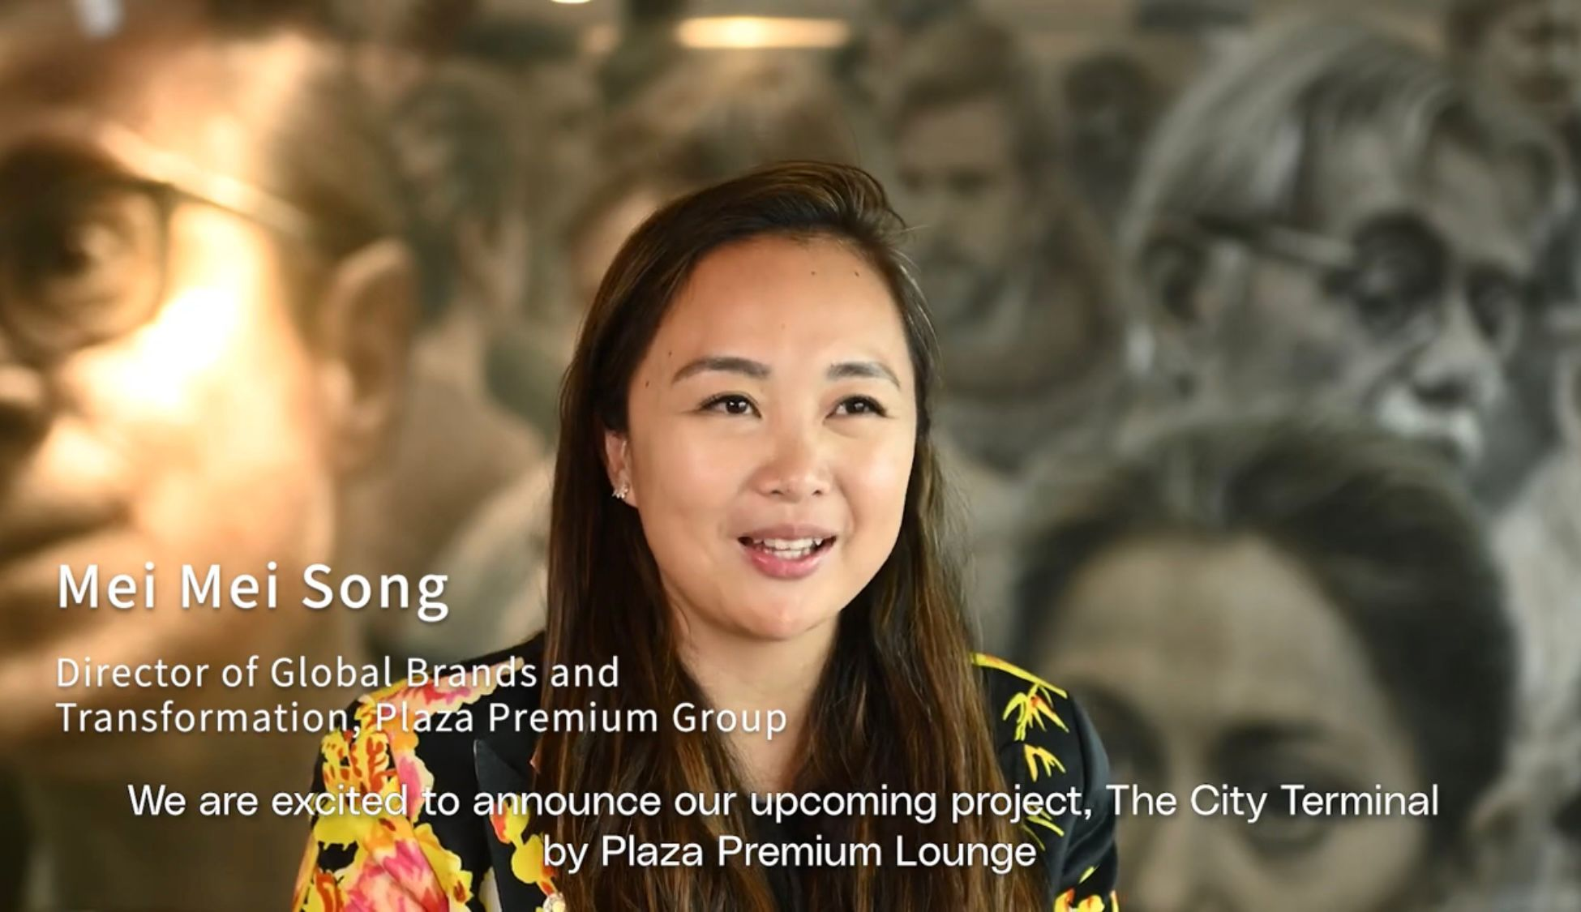](https://youtu.be/zg-86r9NwZs?si=j6RMojvt1vMB_b6L)

**Media Contact:  
Whitney Fung  
 Plaza Premium Group PR & Corporate Communications** whitney.fung@plaza-network.com

**About Plaza Premium Group**

Plaza Premium Group, headquartered in Hong Kong and established in 1998, is a pioneering global airport hospitality services provider. With a mission to Make Travel Better, the group introduced the world's first independent airport lounge concept.   
Today, PPG operates the largest network of international airport lounges worldwide and offers a 360-degree airport experience with 13 brands under its portfolio, spanning over 1600 touchpoints across more than 80 international airports and 30 countries & regions worldwide.

From airport lounge brands - Plaza Premium Lounge & Plaza Premium First, to terminal hotels - Aerotel & Refreshhh by Aerotel, to concierge services - ALLWAYS, a range of airport dining concepts, global reward and membership program - Smart Traveller, and travel experience ECOsystem - oneTECO, the group is at the forefront of transforming airport experience for the better through innovative and human-led solutions. PPG’s commitment extends beyond its own brands, as it also provides lounge management and hospitality solutions to leading airlines, alliances, and corporates worldwide. Partnerships include renowned names such as American Express, Capital One, Cathay Pacific Airways, SkyTeam, Star Alliance, Visa, and many more.

Plaza Premium Group has over 80 accolades demonstrating its exceptional achievements and commitment to service excellence. Notably, the group has received the prestigious "World's Best Independent Airport Lounge" award at the World Airline Awards by Skytrax for eight consecutive years from 2016 to 2024. TTG Asia also recognized the group as the "Best Airport Lounge Operator" in 2018, 2019 and 2023. In 2020, it achieved the "ISO 9001:2015" certification for its Hong Kong Headquarters. Furthermore, the group's Founder and CEO, Mr. Song Hoi-see, was awarded the “Ernst & Young Entrepreneur of the Year” and “Master Entrepreneur of the Year Malaysia” in 2018.

With a team of over 5,000 dedicated talents, PPG serves more than 20 million global passengers annually. Through a continuous pursuit of innovation and excellence, the group is experiencing exponential growth globally.

To learn more: [https://www.plazapremiumgroup.com/](https://apc01.safelinks.protection.outlook.com/?url=https%3A%2F%2Fwww.plazapremiumgroup.com%2F&data=05%7C02%7Cwhitney.fung%40plaza-network.com%7C823ef701a78940596ba708dc8c1f0f36%7C57c780997a6f42de9103b6ff47502aac%7C0%7C0%7C638539312283298306%7CUnknown%7CTWFpbGZsb3d8eyJWIjoiMC4wLjAwMDAiLCJQIjoiV2luMzIiLCJBTiI6Ik1haWwiLCJXVCI6Mn0%3D%7C0%7C%7C%7C&sdata=WJt3N4EG0YzmKgURoRWdOKWSeTVXas86Nat6b9Pb8cE%3D&reserved=0)

Connect with us: FB, IG, @plazapremiumlounge and WeChat @PlazaPremiumGroup

**About JWIDE**

JWIDE is a Japan Inbound Travel & Hospitality Corporation established in 2015, with mission to become “the bridge connecting Japan and the world”.

Its founder & CEO, Mr Nishino Teppei, believes that through continuous discovering of Japan’s “hidden-gem” travel & hospitality resources, curating innovative & personalised journey, providing considerate & excellence service, JWIDE will be the name to bring joyful memories, sense of reliability and travel experience beyond expectations to all its guests, turning more foreign travelers into fans of Japan.

JWIDE is the first to provide in-depth Japan Journey to mid – high end Chinese and global travellers, and is known for its service excellence to offer innovative experience beyond the customer’s expectations. JWIDE has become Ctrip’s core partner in Japan since 2015, and established close partnership with numerous OTAs, Airlines, National Railway, MICE cooperation in China, Japan, Singapore and New Zealand. In 2019, JWIDE served more than 40,000 inbound travelers with ratings of 5-star satisfactory.

JWIDE is an official member of ANTA (全国旅行業協会 All Nippon Travel Agents Association) and a certified Designated Travel Agency of Japan Tourism Agency (日本国土交通省観光庁).