**Plaza Premium First Hong Kong Celebrates Fourth Wins as "Best Independent Airport Lounge"**

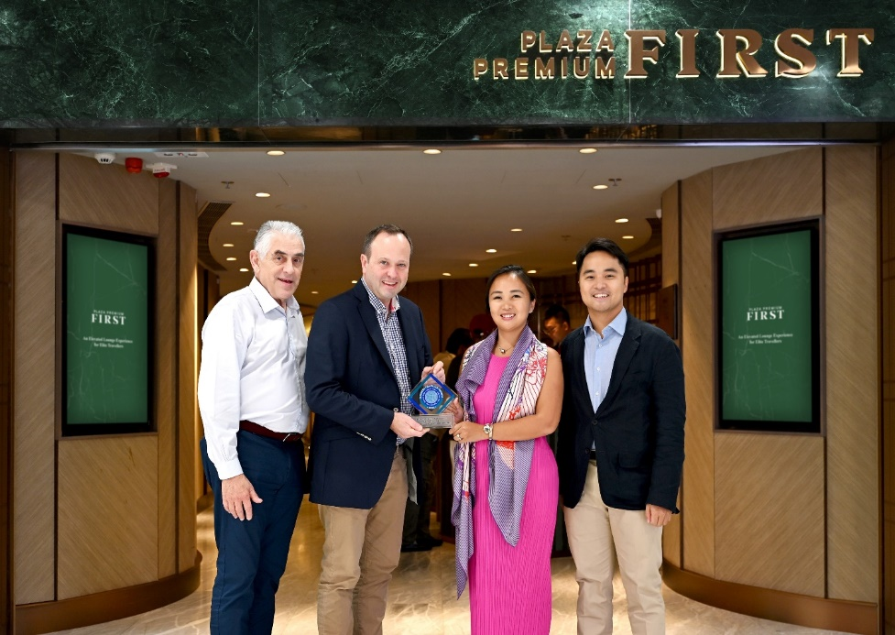

**Julian Gregory, the CEO of Business Traveller presented the "Best Independent Airport Lounge" award to the Plaza Premium Group.   
  
From left to right: John Girard, General Manager, Hong Kong Operations of Plaza Premium Group; Julian Gregory, CEO of Business Traveller ; Mei Mei Song, Chief Transformation Officer of Plaza Premium Group ; Jonathan Song, Chief Commercial Officer of Plaza Premium Group**

[30 th October 2024 - Hong Kong] – Plaza Premium Group (PPG), the leading global airport hospitality services provider, announces that "Plaza Premium First Hong Kong" has once again received the "Best Independent Airport Lounge" at the Business Traveller Asia-Pacific Awards 2024.

This achievement marks the fifth win in this category for PPG, with Plaza Premium First Hong Kong securing this honor for the fourth time. The accolade further amplifies the excitement following recent victories at the Skytrax World Airlines Awards, World Luxury Travel Awards, and World Travel Awards across the global Plaza Premium Lounge network. Over the past decade, the group has garnered over a hundred accolades, demonstrating its exceptional hospitality and unwavering commitment to excellence.  
  
Debuted in Hong Kong in 2018, the Plaza Premium First lounge concept has expanded to four global locations, aiming transforms and elevates the travel experience with personalized hospitality, made-to-order signature dishes and a cross-brand journey for elite travellers. With a mission to make travel better, PPG constantly introduces new experiences to travellers. Recently, the group unveiled the “Infinity Room” - a lounge within a lounge concept at Plaza Premium First Hong Kong, offering enhanced luxury, privacy, and personalization to further enrich one's journey.

Mr. Song Hoi See, Founder and CEO of Plaza Premium Group said: "We are honored to receive another prestigious Business Traveller award. A heartfelt thank you to all the voters, our customers, and our dedicated team. Hong Kong is our home base, and we began our journey at Hong Kong International Airport 26 years ago; for our team here to receive an award means a lot to us. At Plaza Premium Group, we have always believed that the airport is a destination where the experience truly matters. The award motivates us to continue raising the bar and making travel better for passengers."

**About Plaza Premium Group**

Plaza Premium Group, headquartered in Hong Kong and established in 1998, is a pioneering global airport hospitality services provider. With a mission to Make Travel Better, the group introduced the world's first independent airport lounge concept. 

Today, PPG operates the largest network of international airport lounges worldwide and offers a 360-degree airport experience with 14 brands under its portfolio, spanning over 1600 touchpoints across more than **75** international airports and 30 countries & regions worldwide.

From airport lounge brands - Plaza Premium Lounge & Plaza Premium First, to terminal hotels - Aerotel & Refreshhh by Aerotel, to concierge services - ALLWAYS, a range of airport dining concepts, global reward and membership program - Smart Traveller, and travel experience ECOsystem - oneTECO, the group is at the forefront of transforming airport experience for the better through innovative and human-led solutions. PPG’s commitment extends beyond its own brands, as it also provides lounge management and hospitality solutions to leading airlines, alliances, and corporates worldwide. Partnerships include renowned names such as American Express, Capital One, Cathay Pacific Airways, SkyTeam, Star Alliance, Visa, and many more.

Plaza Premium Group has over **100 accolades** demonstrating its exceptional achievements and commitment to service excellence. Notably, the group has received the prestigious "World's Best Independent Airport Lounge" award at the World Airline Awards by Skytrax for eight consecutive years from 2016 to 2024. TTG Asia also recognized the group as the "Best Airport Lounge Operator" in 2018, 2019 and 2023. In 2020, it achieved the "ISO 9001:2015" certification for its Hong Kong Headquarters. Furthermore, the group's Founder and CEO, Mr. Song Hoi-see, was awarded the “Ernst & Young Entrepreneur of the Year” and “Master Entrepreneur of the Year Malaysia” in 2018.

With a team of over 5,000 dedicated talents, PPG serves more than 20 million global passengers annually. Through a continuous pursuit of innovation and excellence, the group is experiencing exponential growth globally.

 To learn more: [https://www.plazapremiumgroup.com/](https://apc01.safelinks.protection.outlook.com/?url=https%3A%2F%2Fwww.plazapremiumgroup.com%2F&data=05%7C02%7Cwhitney.fung%40plaza-network.com%7Cb73228f69649471153ed08dc8c4b2e82%7C57c780997a6f42de9103b6ff47502aac%7C0%7C0%7C638539501783740352%7CUnknown%7CTWFpbGZsb3d8eyJWIjoiMC4wLjAwMDAiLCJQIjoiV2luMzIiLCJBTiI6Ik1haWwiLCJXVCI6Mn0%3D%7C0%7C%7C%7C&sdata=e1yaoen78nb4kWIILR4XwqpHpbtRvi5CKGWQ1hcLd0A%3D&reserved=0)

Connect with us: FB, IG, @plazapremiumlounge and WeChat @PlazaPremiumGroup

Media contact:  
Whitney Fung   
Plaza Premium Group PR & Corporate Communications   
[whitney.fung@plaza-network.com](mailto:whitney.fung@plaza-network.com)