**Plaza Premium Group announces Joint Venture with Cairo Airport Company and Egypt Aviation Services   
at Cairo International Airport**

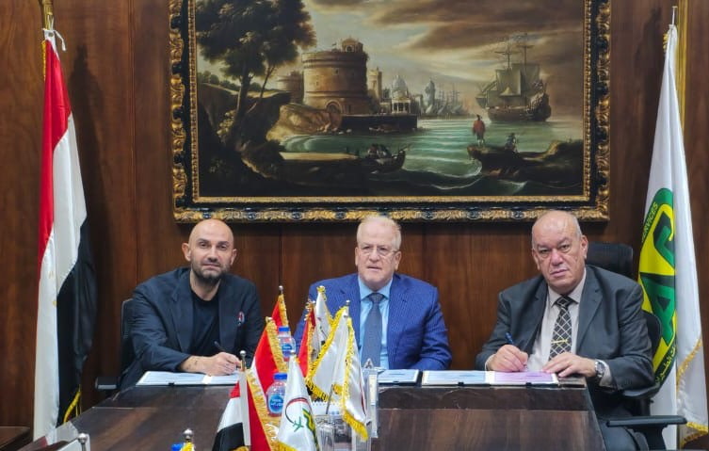

Plaza Premium Group (PPG) signed a Memorandum of Understanding which confirms the joint venture with the Cairo Airport Company (CAC) and Egypt Aviation Services (EAS). Present at the MOU Signing (from left to right) Okan Kufeci, Senior Vice President-Europe, of Middle East and Africa, General Mohamed Kamel Moustafa, Chairman and Managing Director of Egypt Aviation Services and Magdy Ishak Azzer, Chairman and Chief Executive Officer of Cairo Airport Company.

[Cairo, Egypt, 2 JAN 2024] – Plaza Premium Group (PPG), the leading global airport hospitality services provider, Egypt Aviation Services (EAS), and Cairo Airport Company (CAC) have announced a strategic joint venture. Under this collaboration, PPG will manage, operate, and commercialise six lounges across various terminals at Cairo International Airport (CAI), leveraging PPG’s global expertise in creating award-winning airport hospitality experiences. The Lounges will be rebranded as Plaza Premium Lounge by CAC and EAS.

CAC has assigned the full management of CAC VIP Lounges to a joint venture formed between EAS and PPG, who have taken over six Lounges in Terminals 1, 2, 3 and the Seasonal Terminal of the Cairo International Airport. Furthermore, a new lounge by the F Gates of Terminal 3 is being developed.  
  
This landmark partnership marks the official market entry of PPG into Egypt, another important milestone in the company’s expansion in the MENA region, alongside its recent expansions into other key markets in the region, such as Saudi Arabia, Kenya and Abu Dhabi. Cairo International Airport (CAI) is a pivotal hub for air travel in Egypt and the broader region, playing a significant role in the country's economy and connectivity. It is the busiest airport in the country and Africa, handling 26.4 million passengers in 2023 and has non-stop passenger flights scheduled to 125 destinations in 62 countries.

“This unprecedented partnership with Egyptian Aviation Services (EAS), and Cairo Airport Company opens up exciting opportunities for our first entry into the Egyptian market through this strategic partnership, bringing our global standards and expertise in delivering award-winning airport hospitality experiences to Cairo. We are committed to our mission of making travel better for all passengers flying through Cairo International Airport with our portfolio of Plaza Premium Lounges,” stated Okan Kufeci, Senior Vice President-Europe, Middle East and Africa.

The strategic importance of Cairo International Airport serves as a gateway for tourists visiting Egypt which accounts for 80% of passenger traffic and it is also a major hub for business travellers and cargo transport across continents.

“Egypt represents a burgeoning market in global tourism, with Cairo International Airport being a key hub, connecting travellers to Egypt and across Africa and the MENA region. We are committed to enhancing the airport experience and supporting Egypt’s vision in becoming a premier global destination. Therefore, we are pleased to forge a joint venture with Plaza Premium Group in collaboration with the Egyptian Airport Services to embark on a new era of world-class airport hospitality,” stated Magdy Ishak Azzer, Chairman and Chief Executive Officer of Cairo Airport Company.

“The opportunities arising from the travel and tourism industry in Egypt is growing exponentially, driven by increased passenger traffic, new routes and expanded capacity among leading airlines. We are pleased to collaborate with PPG in amplifying Egypt's reputation as a global aviation hub by optimizing passenger experiences and services in the multiple airport lounges within the Cairo International Airport,” stated General Mohamed Kamel Moustafa, Chairman and Managing Director of Egypt Aviation Services.

The future of Egypt’s tourism sector is promising, with projections indicating the overall travel and tourism market to grow by 5.98% annually. In the first half of 2024, Egypt's tourism sector revenues grew by 5% to $6.6 billion, compared to $6.3 billion in the same period of 2023. The country aims to reach 30 million tourists by 2028 and to increase airport capacity by 50% by 2030.

With PPG’s extensive presence in its key source markets including Turkey, Saudi Arabia, Dubai, Abu Dhabi, and other fast-emerging markets, especially China, its world-class airport hospitality services will be able to cater to travellers from departure, transit, to return.

**About Plaza Premium Group**

Plaza Premium Group, headquartered in Hong Kong and established in 1998, is a pioneering global airport hospitality services provider. With a mission to Make Travel Better, the group introduced the world's first independent airport lounge concept.

Today, PPG operates the largest network of international airport lounges worldwide and offers a 360-degree airport experience with 14 brands under its portfolio, spanning over 1,600 touchpoints in 150 countries across 600 international and domestic airports. From airport lounge brands - Plaza Premium Lounge & Plaza Premium First, to terminal hotels - Aerotel & Refreshhh by Aerotel, to concierge services - ALLWAYS, a range of airport dining concepts, global reward and membership program – Smart Traveller, and travel experience ECOsystem - oneTECO, the group is at the forefront of transforming airport experience for the better through innovative and human-led solutions. PPG’s commitment extends beyond its brands, as it also provides lounge management and hospitality solutions to leading airlines, alliances, and corporates worldwide. Partnerships include renowned names such as American Express, Capital One, Cathay Pacific Airways, SkyTeam, Star Alliance, Visa, and many more.

Plaza Premium Group has over 100 accolades demonstrating its exceptional achievements and commitment to service excellence. Notably, the group has received the prestigious "World's Best Independent Airport Lounge" award at the World Airline Awards by Skytrax for eight consecutive years from 2016 to 2024. TTG Asia also recognized the group as the "Best Airport Lounge Operator" in 2018, 2019 and 2023. In 2020, it achieved the "ISO 9001:2015" certification for its Hong Kong Headquarters. Furthermore, the group's Founder and CEO, Mr. Song Hoi-see, was awarded the “Ernst & Young Entrepreneur of the Year” and “Master Entrepreneur of the Year Malaysia” in 2018.

With a team of over 6,000 dedicated talents, PPG serves more than 20 million global passengers annually. Through a continuous pursuit of innovation and excellence, the group is experiencing exponential growth globally.

To learn more: [https://www.plazapremiumgroup.com/](https://apc01.safelinks.protection.outlook.com/?url=https%3A%2F%2Fwww.plazapremiumgroup.com%2F&data=05%7C02%7Cwhitney.fung%40plaza-network.com%7C1388a42c08e743d19cb308dd09e20913%7C57c780997a6f42de9103b6ff47502aac%7C0%7C0%7C638677588625685697%7CUnknown%7CTWFpbGZsb3d8eyJFbXB0eU1hcGkiOnRydWUsIlYiOiIwLjAuMDAwMCIsIlAiOiJXaW4zMiIsIkFOIjoiTWFpbCIsIldUIjoyfQ%3D%3D%7C0%7C%7C%7C&sdata=155%2BwPAzyJDsY7VXvQ844zzRHEp55%2Bemp3z9ZbznUpA%3D&reserved=0)

Connect with us: FB, IG, @plazapremiumlounge and WeChat @PlazaPremiumGroup

Media Contact:   
Whitney Fung  
Plaza Premium Group   
PR & Corporate Communications  
  
[whitney.fung@plaza-network.com](mailto:whitney.fung@plaza-network.com)