For Immediate Release
Plaza Premium Group and Hong Kong Airlines
Sign Landmark MOU to Elevate Guest Experience

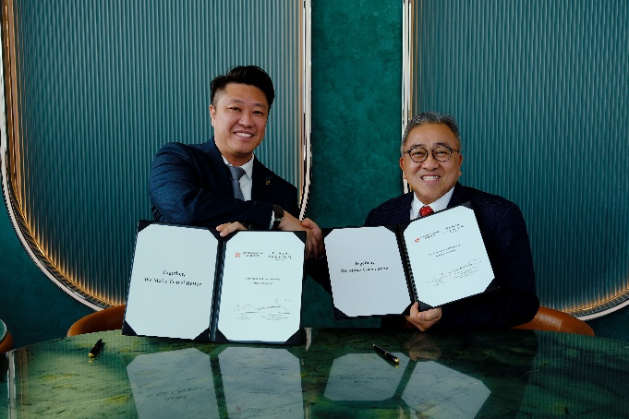 | 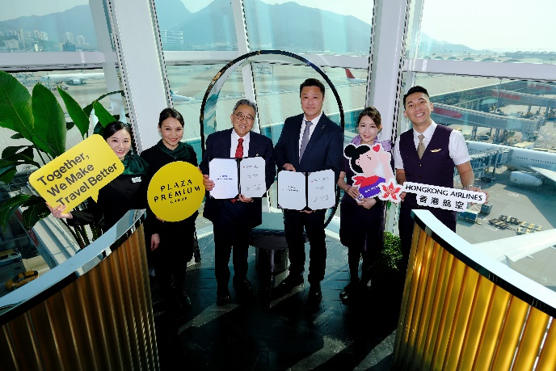
Chairman of Hong Kong Airlines, Mr. Yan Bo (left) and Founder & CEO of Plaza Premium Group, Mr. Song Hoi See (right) at the MOU signing ceremony | Mr. Song Hoi See (third left) & Mr. Yan Bo (third right) with the staff from Plaza Premium Group and cabin crew from Hong Kong Airlines

Hong Kong, 31 March 2025 - Plaza Premium Group (PPG), the global leader in integrated airport hospitality services, and Hong Kong Airlines (HKA), the Hong Kong based full-service airline, signed a Memorandum of Understanding (MOU) to enhance cooperation and extend the range of services available to their respective guests. This strategic partnership aims to leverage PPG's expertise in global airport hospitality and HKA's commitment to elevating the global travel experience for passengers.
Under this arrangement, business class passengers and frequent flyer members of Hong Kong Airlines would be eligible to access Plaza Premium Lounges worldwide. Currently, HKA operates a network of over 30 destinations across Asia Pacific and North America. PPG operates its flagship Plaza Premium Lounges in over 150 countries worldwide, covering almost all the destinations in HKA’s network. This year, the airline is launching long-haul routes to further expand its network and Plaza Premium Lounges are already operating at these destinations.
As part of the cooperation in the future, PPG and HKA will also develop integrated benefits on their respective loyalty programmes – Smart Traveller is the digital experience and rewards platform for Plaza Premium Group, in conjunction with Fortune Wings Club, the global loyalty programme for Hong Kong Airlines. This includes promotions that facilitate the conversion of points on each other’s loyalty programmes. There will also be the opportunity to redeem points accumulated on the Smart Traveller marketplace for HKA’s special offers, including e-vouchers and seasonal promotions. The two parties also plan to develop marketing campaigns to cross promote Hong Kong Airlines ticket packages and bundle them with the Smart Traveller’s global programme of services and products.

There will also be an opportunity to jointly develop social impact programmes that will support community-driven initiatives aimed at achieving shared social responsibility goals.
Commenting on the partnership, Mr. Song Hoi See, Founder and CEO of Plaza Premium Group, “We are delighted to collaborate with Hong Kong Airlines to extend our global portfolio of airport lounges and services to the business class passengers and frequent flyer members of Hong Kong Airlines. This strategic partnership is important for us to deliver an elevated customer experience to Hong Kong Airlines passengers. We also aim to bring the best of both our company’s innovative digital experience and rewards platform, Smart Traveller, together with the Fortune Wings Club, the global loyalty programme of Hong Kong Airlines, which will offer a more seamless customer experience for travellers”.
Mr. Yan Bo, Chairman of Hong Kong Airlines said, “We are excited to join forces with PPG to make our passengers’ travel experience even better. As one of the major home carriers in Hong Kong, HKA has been growing steadily, and this year, we resumed flights to Australia and Canada, marking our return to the long-haul market. Through this collaboration, our business class passengers and frequent flyers will enjoy access to PPG’s extensive network of premium lounges worldwide, ensuring exceptional journey at every step. In addition, by integrating our loyalty programmes, we are unlocking exciting new rewards and benefits for customers. The partnership not only strengthens our global presence but also aligns with our shared commitment to excellence and innovation in aviation and hospitality."

Download high-resolution photos here.

About Plaza Premium Group
Plaza Premium Group (PPG) is the global leader in integrated airport hospitality and passenger service solutions, operating the largest network of airport lounges worldwide and offering a 360-degree airport hospitality experience with 14 brands under its portfolio, operating in 150 countries across 600 international and domestic airports and serving 24 million passengers annually. With a mission to Make Travel Better, the group introduced the world's first independent airport lounge concept in 1998.
Plaza Premium Lounge, Plaza Premium First - award-winning airport lounges, Aerotel - the world’s largest airport transit hotel chain, Refreshhh by Aerotel, ALLWAYS - airport passenger services, airport dining concepts, Smart Traveller - innovative digital experience and rewards platform, and One Travel Experience Ecosystem (oneTECO), the group is at the forefront of transforming airport experiences for the better through innovative and human-led solutions. PPG’s commitment extends beyond its brands, as it also provides lounge management and hospitality solutions to leading airlines, alliances, and corporates worldwide. Partnerships include renowned names such as American Express, Capital One, Cathay Pacific Airways, SkyTeam, Star Alliance, Visa, and many more.

Smart Traveller is Plaza Premium Group's global digital rewards program designed to enhance airport experiences for travellers. It offers exclusive rewards and tailored benefits for every journey, whether departing, in transit, or arriving. The Smart Traveller app includes features such as Link My Card for easy lounge access, Flight Information Displays (FIDs) for real-time flight updates, and Smart Order for convenient food and beverage service. With Smart Traveller, travellers can access over 100 Plaza Premium Lounge and Plaza Premium First locations worldwide, offering relaxation before flights. Rewards can be earned not only through lounge visits but also from dining at selected outlets and hotel stays, allowing travellers to accumulate points redeemable for various airport services and travel experiences.
Plaza Premium Group has over 100 accolades, demonstrating its exceptional achievements and commitment to service excellence. Notably, the group has received the prestigious "World's Best Independent Airport Lounge" award at the World Airline Awards by Skytrax for eight consecutive years from 2016 to 2024.
With a team of over 6,000 dedicated talents worldwide, and through a continuous pursuit of innovation and excellence, the group is experiencing exponential growth globally.
To learn more: https://www.plazapremiumgroup.com/
Connect with us: LinkedIn, Facebook, Instagram @PlazaPremiumLounge, IG @mysmarttraveller, X, and YouTube

About Hong Kong Airlines
Established in 2006, Hong Kong Airlines is a full-service airline firmly rooted in Hong Kong. The airline flies to over 30 destinations across the Asia Pacific and North America, and currently maintains interline and codeshares with multiple airline partners and ferry service providers. Hong Kong Airlines operates an all-Airbus fleet. It has been awarded the internationally acclaimed four-star rating from Skytrax since 2011. For more information, please visit hongkongairlines.com or our social media channels on LinkedIn, Twitter, Instagram and Facebook.
For all media inquiries, please contact:
Virginia Luk
Global PR & Corporate Communications, Plaza Premium Group
E-mail: virginia.luk@plaza-network.com
Rodman Chan
Corporate Communications, Hong Kong Airlines
Email: corpcomm@hkairlines.com

