FOR IMMEDIATE RELEASE
Plaza Premium Group Partners with International Board of Credentialing and Continuing Education Standards to
Enhance Global Accessibility Training and Services

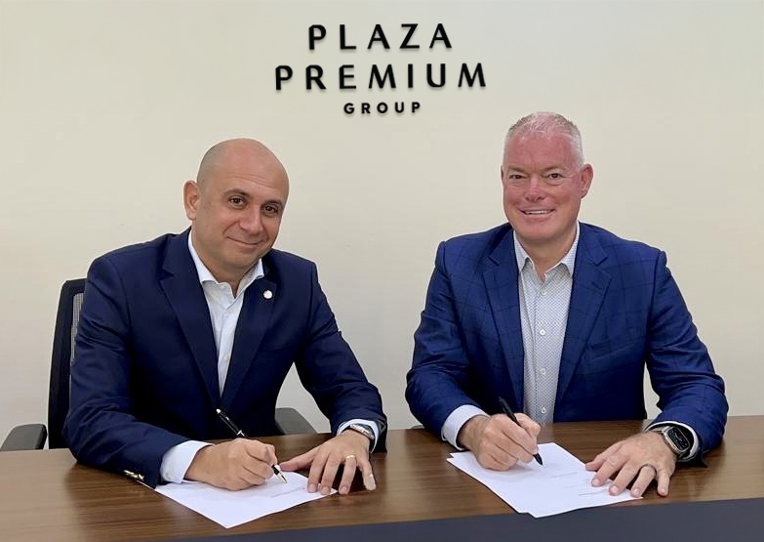
Deputy CEO of Plaza Premium Group, Bora Isbulan (left) and Myron Pincomb, CEO & Board Chairman of International Board of Credentialing and Continuing Education Standards (right) at the MOU signing ceremony

[Hong Kong — 28 May 2025] Plaza Premium Group (PPG), the global leader in integrated airport hospitality services and the International Board of Credentialing and Continuing Education Standards (IBCCES), the leading authority in cognitive difference training and certification for professionals, are proud to announce a strategic partnership aimed at elevating accessibility and services for airport passengers with mobility challenges and disabilities worldwide.
As part of the partnership, over 3,000 frontline staff of PPG will undergo IBCCES training and certification. This training will enable staff to better understand and support airport passengers with hidden disabilities. Training will begin with lounge leaders in key locations, including Hong Kong, Canada, Malaysia, United Kingdom, and Italy, through classroom sessions, furthermore, lounge managers and supervisors will be trained and certified to identify and appropriately assist individuals with hidden disabilities. Following this, a global rollout will extend the training across all Plaza Premium Group lounges to ensure consistent, high-quality support for all passengers with diverse accessibility needs, reinforcing PPG’s commitment to accessibility.
Additionally, IBCCES will feature up to 200 of PPG’s business units, including lounges, hotels, dining outlets, and airport passenger services, on its global app. The IBCCES Accessibility App features a variety of tools and resources that are used by millions of members who have accessibility challenges and/or hidden disabilities, as well as their families and caregivers.
IBCCES will also conduct on-site audits at selected lounges to assess and guide improvements in accessibility standards, helping us create more inclusive environments suitable for passengers with mobility challenges and/or hidden disabilities.
Under this partnership, PPG will introduce its airport, airline and other aviation partners to IBCCES, enabling IBCCES to leverage PPG’s relationships to gain access to airports and airlines worldwide.
Bora Isbulan, Deputy CEO of Plaza Premium Group, said, “We are excited to partner with IBCCES to further our ESG and social impact commitment in providing inclusive and exceptional hospitality experiences. This collaboration aligns with our efforts to ensure that all travellers feel welcome and supported throughout their journey, making travel better for all.”
“Our mission is to ensure accessibility is woven into every step of the travel journey—not treated as an afterthought,” said Myron Pincomb, CEO & Board Chairman of IBCCES. “Partnering with a global leader like Plaza Premium Group allows us to accelerate that mission and drive cultural change within the travel industry on a global scale. This is about creating real, sustainable impact for millions of travellers around the world.”
This partnership marks a significant step forward in elevating airport hospitality and meeting the growing demand for inclusive services in the aviation sector, reflecting both organizations’ dedication to inclusivity and customer satisfaction.

Download high-resolution photos here.

About Plaza Premium Group
Plaza Premium Group (PPG) is the global leader in integrated airport hospitality and passenger service solutions, operating the largest network of airport lounges worldwide and offering a 360-degree airport hospitality experience with 14 brands under its portfolio, operating in 150 countries across 600 international and domestic airports and serving 24 million passengers annually. With a mission to Make Travel Better, the group introduced the world's first independent airport lounge concept in 1998. Plaza Premium Lounge, Plaza Premium First - award-winning airport lounges, Aerotel - the world’s largest airport transit hotel chain, Refreshhh by Aerotel, ALLWAYS - airport passenger services, airport dining concepts, Smart Traveller - innovative digital experience and rewards platform, and One Travel Experience Ecosystem (oneTECO), the group is at the forefront of transforming airport experiences for the better through innovative and human-led solutions. PPG’s commitment extends beyond its brands, as it also provides lounge management and hospitality solutions to leading airlines, alliances, and corporations worldwide. Partnerships include renowned names such as American Express, Capital One, Cathay Pacific Airways, Saudia, SkyTeam, Star Alliance, Visa, and many more. Plaza Premium Group has over 100 accolades, demonstrating its exceptional achievements and commitment to service excellence. Notably, the group has received the prestigious "World's Best Independent Airport Lounge" award at the World Airline Awards by Skytrax for eight consecutive years from 2016 to 2024. With a team of over 6,000 dedicated professionals worldwide, and through a continuous pursuit of innovation and excellence, the group is experiencing exponential growth globally.
To learn more: https://www.plazapremiumgroup.com
Connect with us: LinkedIn, YouTube: @Plaza Premium Group; Facebook, Instagram: @plazapremiumlounge; X: @We_Are_PPG; WeChat, Weibo, Xiaohongshu: @環亞全球出行PlazaPremiumGroup; Instagram (mysmarttraveller): @mysmarttraveller

About IBCCES
Delivering the global standard for training and certification in the fields of autism, neurodiversity, and accessibility – IBCCES provides a series of certification programs that empower professionals to be leaders in their field and improve the outcomes for the individuals they serve. For over two decades, IBCCES has been a global leader, setting the industry standard in autism and cognitive differences training. IBCCES works in over 111 countries and provides training in 8 languages, and its programs have been recognized around the world as the leading benchmark in training and certification. In addition to individual certification programs, IBCCES partners with cities, destinations, and organizations on initiatives like the Certified Autism Destination™ (CAD) and Autism Certified City™ (ACC), ensuring autistic and sensory-sensitive residents and visitors feel welcomed and safe. Destinations that achieve the CAD designation have completed a specialized program that ensures a multitude of recreation, hospitality and entertainment organizations have completed an autism and sensory-sensitivity training, certification and IBCCES facilities review process. The ACC designation expands on that program and includes IBCCES training and certification for the public safety, education, healthcare and workplace sectors.
IBCCES also created the Accessibility App, AutismTravel.com, and CertifiedAutismCenter.com – free resources for individuals with a variety of neurodiversities and disabilities, listing certified locations and connecting individuals to other resources and each other.

Media Contact:
Virginia Luk
Plaza Premium Group
PR & Corporate Communications – Global
Email: virginia.luk@plaza-network.com

